Issues Identified UI Test

Usability Issues

User Registration

1. Password requirement .

- Application is advising the user about the requirement of password upfront

- Error/warning message about password requirement is not complete as its prompting one error at a time until user make all satisfy password requirement complete. which will make user annoyed and will not think of proceeding with registration.

Defect UI 1 will talk more about this

2.From Home Screen user need to click on Image of tiles to take to sub screen, not by clicking on anywhere in the tile

Example: Popular Make tile text will not take user to its respective screen

Defect UI

1. Registration password doesn’t accept due to incomplete and misleading errors messages

1. Open Register

2. Enter Password and confirm password with text "water"

3. Error InvalidParameter: 1 validation error(s) found. - minimum field size of 6, SignUpInput.Password.

Defect 1 : When user satisfy requirement as per message size of 6 as "animal" password New error follows InvalidPasswordException: Password did not conform with policy: Password not long enough

Defect 2: When user enter 8 character text as password, new error appear as Password must have uppercase characters

Defect 3: When user enter 8 Character text with one upper case letter. New error appears Password must have numeric characters

Defect 4: when user enter 8 Character text with one upper case letter and number. New error Password must have symbol characters

2. Buggy Rating title on top page banner is not returning user to Home screen

Steps

1. Goto Home screen

2. click on Popular Make image to take to Alfa Romeo screen

3. Click on Buggy Rating from the Top banner

Expected

Should take application back to home page

Actual

On click it will stay in same screen

This option is also not working from Lancia page (https://buggy.justtestit.org/make/c4u1mqnarscc72is013g)

Addition Info

This feature works for other child screens Popular Model and Overall Rating

3. Sort is not working in popular models page for Model and Rank

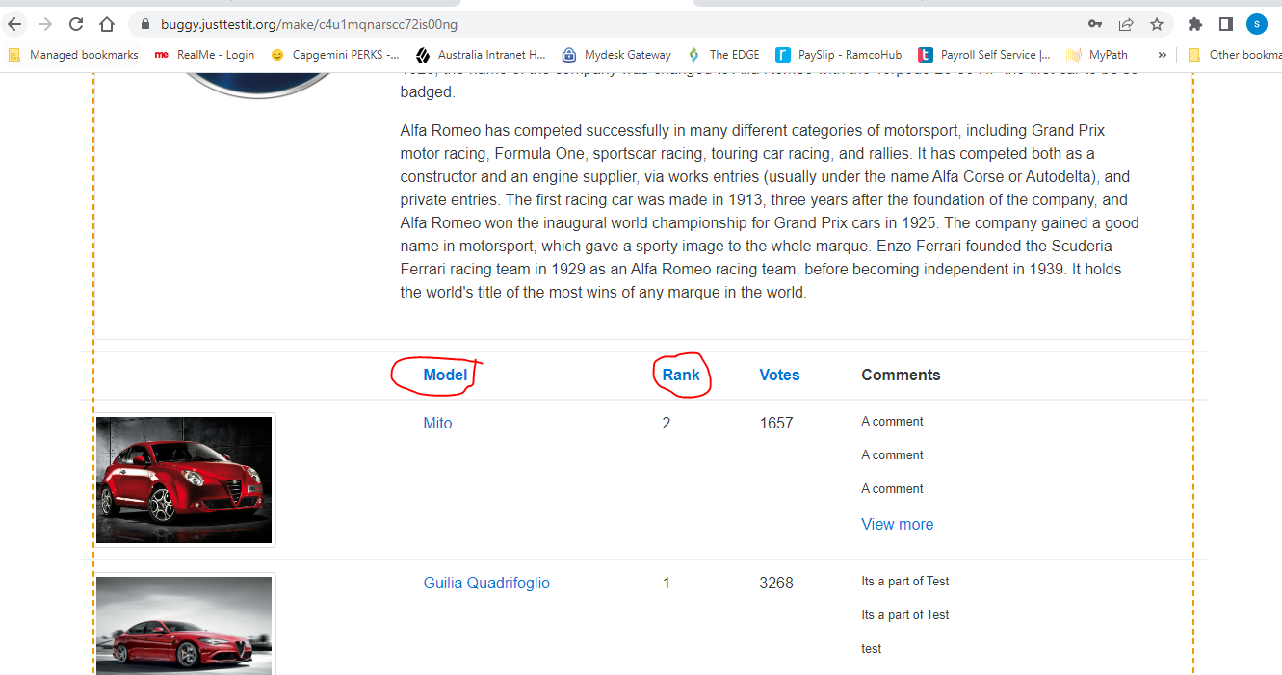

4. Sort is random instead of ascending or descending for Votes in Popular Make page

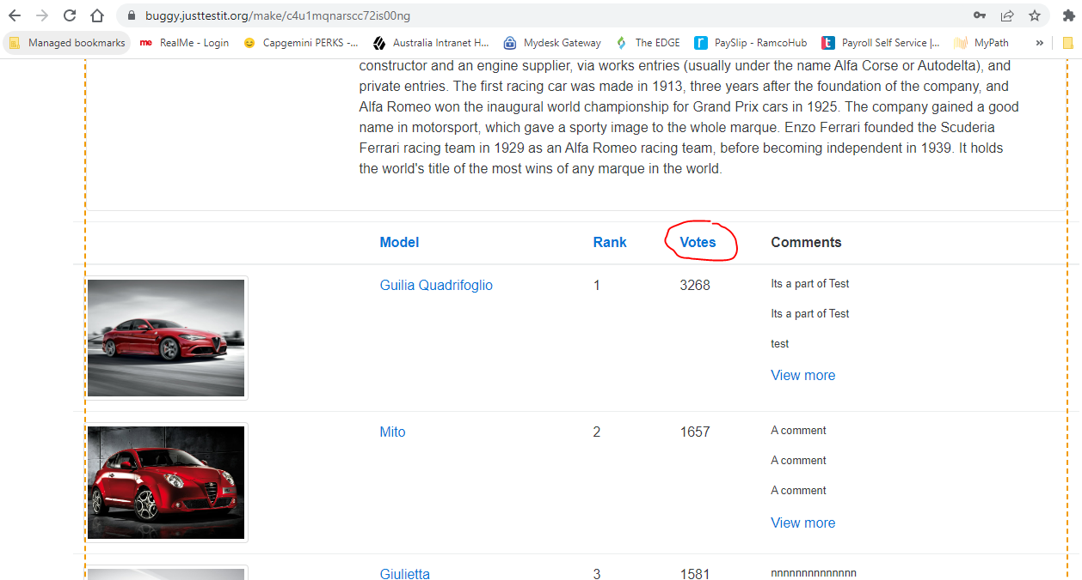

5. Lancia Ypsilon image is missing or unable to load 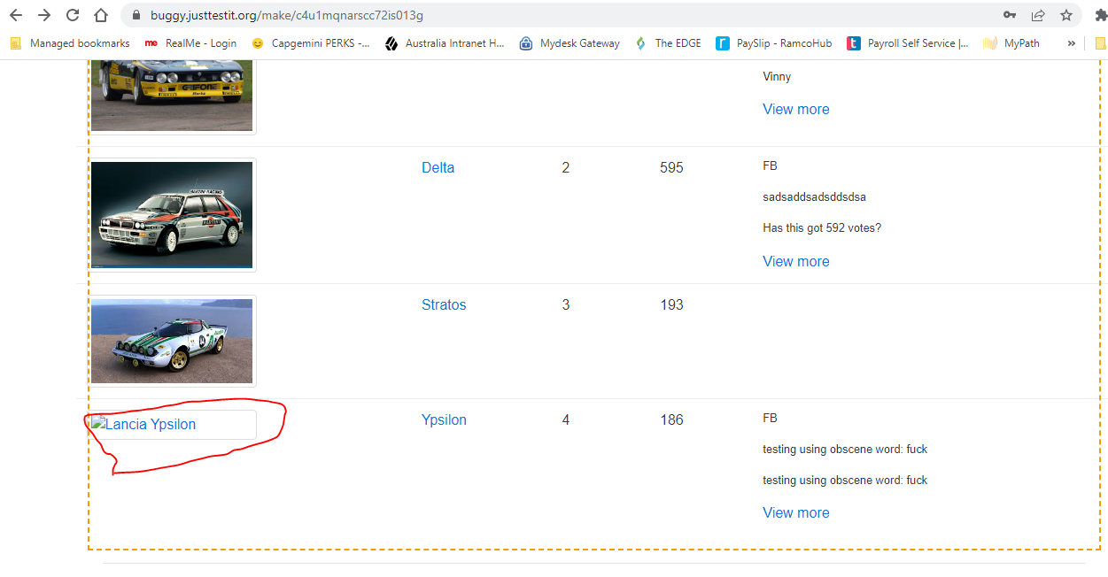

6. Lengthier Vote Comments for Cars are not getting word wrap to next line, instead it extending page to the right

7. Sort option in overall rating page for the field Votes are working as random instead of ascending or descending